Task No & Title: Unit 2 | Unit Descriptor This unit covers the skills and knowledge required to organize and complete own work activities, and obtain feedback on work performance
Title: | BSBCMN202A Organize and complete daily work activities
Suitable for Classes: | Certificate II Business
Area: | Technology & Enterprise
Teacher: | Mr Peter Faulks
Timeline | 1 Lesson
Date Due: | Today

Task Brief:

Files Required

Items highlighted in yellow are tasks for you to complete
Items in Blue are help tips

Unit | Number | Title | Study Time
1 | BSBCMN201A | Work effectively in a business environment | 20
2 | BSBCMN202A | Organize and complete daily work activities | 15
3 | BSBCMN203A | Communicate in the workplace | 30
4 | BSBCMN204A | Work effectively with others | 20
5 | BSBCMN205A | Use business technology | 30
6 | BSBCMN211A | Participate in workplace safety procedures | 15
7 | BSBCMN213A | Produce simple word processed documents | 40
8 | BSBCMN214A | Create and use simple spreadsheets | 20
9 | BSBCMN108A | Develop keyboard skills | 40
10 | BSBCMN107A | Operate a Personal Computer | 20
11 | ICAITU013C | Integrate Commercial computer packages | 30
12 | ICAITU012C | Design Organizational Documents using computer | 50
 |  | TOTAL

Task: Set Up A Cover Page

Create a cover page
A Cover Page for all correspondence and reports (with your name and title of document on it) – see sample
Your cover page must include:

Your name
The title (?????????????)
Title of task/assignment (Portfolio cover)
Teacher’s name (Mr Faulks)
The date it was submitted
If an Essay include the number of words
A marks box

Also may include
Your logo or appropriate image
A relevant Photo or a Photograph of you

A suitable image or background may add to improve the look of the page.

Text should be Arial 11pt and 1.5 lines paragraph
Include a Bibliography and a Table of Contents
Plus this signed by you.

Signature: I ________________________ advise that this work submitted is my own work and has not been copied or reproduced without reference to the appropriate author.

1. Cover Page sample

Cover Page Sample (make yours as exciting as possible)



Presentation by
Your name

Presentation for

TTT Travel
Title of the topic
"The Impact (positive and negative)
of communications technologies on the travel business."

Teachers Name:
Mr Faulks
Date Due: date
Date Submitted: Today's date

Marks | Logo | Photo
 |  | 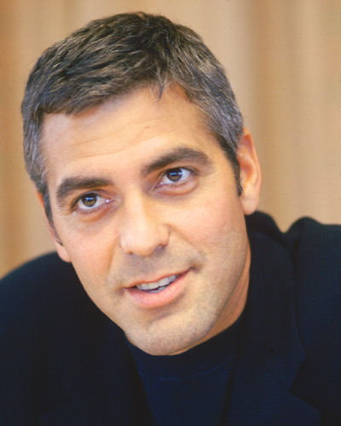
Signature: I ________________________ advise that this work submitted is my own work and has not been copied or reproduced without reference to the appropriate author

Second and subsequent pages should have headers and footers.
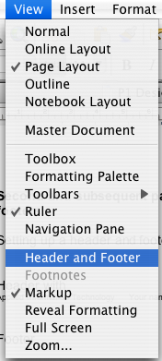

Setting up a header and footer

From the view menu click on
Header and Footer

Header with

Applied Information Technology Your name Year

Switch to footer

Footer
Insert page numbers

Page Number of Pages i.e. Page 1 of 3 Date (use Insert date) File: (Where is the file)

Footer

Page 1 of 3 Date (use Insert date) File: (Where is the file)

Office 2007
Insert Header and choose style
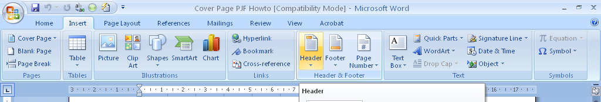

Sample Cover page Follows

Your name

Title

Date Submitted

Number of words

Signature: I ________________________ advise that this work submitted is my own work and has not been copied or reproduced without reference to the appropriate author

Marks | Logo | Photo

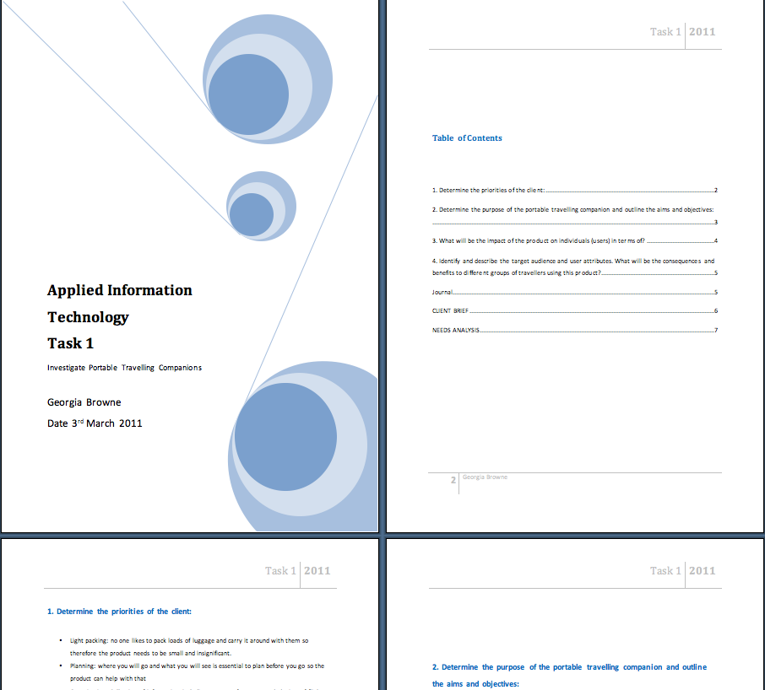

Sample of non-acceptable cover page

What is missing?

Set up a cover page for presentation of Certificate II in Information Technology or Business tasks

Presentation: A single cover page that presents your work in a professional manner

This should be one page with or without borders and include:

Name: Your name

Title: Certificate II in Business/Information Technology

Task Number i.e. 1.5

Task Name presented i.e. Cover Page

Graphic: Picture of you or appropriate clip art for topic being covered

Save the work

Student Name: | Date submitted:
I declare this evidence to have been produced by me the undersigned.

Candidate’s signature:
Title of Portfolio evidence presented : Enter title here
BSBCMN202A Organize and complete daily work activities section 02:????
□ Outcomes from learning programs (including self-learning and online learning)
□ Assessment feedback (from a trainer or assessor)
□ Observation checklists (from a workplace supervisor or assessor)
□ Written statements or references (including workplace supervisors, community leaders)
□ Job descriptions
□ Work journal
□ Work samples
□ Finished products
□ Product descriptions or specifications (supporting the product samples included)
□ Statutory declarations
□ List others (or delete any from above not provided)
- All work submitted to be word processed and spell checked.
- There must be at least two samples of evidence for each
Element within the Unit of Competency. This is sample 1 / 2
- All work submitted must be of a high quality and meet the
requirements of the Unit of Competency.
Other evidence (List each piece):
Assessor to complete
Evidence is Valid Sufficient Authentic Current
□ □ □ □

Assessor signature: _________________________________Date: _____________
Peter Faulks, BA Soc Sci, Grad Dip Ed, Cert IV AWT
Certificate II in Business assessor/teacher
Assessor to complete

Student is declared Competent Not Yet Competent
□ □

Keep a copy of this report with your file for evidence

